INS3121
January 19th, 2018

Group 4: Assoc . Prof. Dr. Pelin Özener
Group 5: Asst. Prof. Dr. Nejat N. Çetinkaya
SOIL MECHANICS
FINAL MAKE-UP EXAM
Q.1/20p | Q.2/20p | Q.3/20p | Q.4/20p | Q.5/20p | TOTAL
Student Name Surname:
Number:
Group:

a) Briefly describe the differences between consolidation and compaction.

- Select the correct word in the statements below regarding the internal friction angle of sandy soils.
  - The internal friction angle of sands increases / not changes / decreases with increasing relative density.
  - Well graded sands have a higher / lower internal friction than poorly graded sands.
  - Sands that have rounded grains have a higher / lower internal friction than those that have angular grains.
- Describe the following abbreviations.
CH :
SM :
GP :
I_{p} :
c_{u} :

- Plot the typical compaction curves obtained from standart proctor test and modified proctor test and show the compaction parameters obtained from these tests.

- An excavation will be opened in the soil profile shown in the below figure. The permeable soil layer underlying the clay was observed to be under the artesian pressure. If the water in the drill hole rose to a height of 7 m above the permeable layer,

- Compute the factor of safety against heaving if the excavation reaches a depth of H=6 m.
- How deep (H) can the excavation proceed before the bottom heaves?
- Compute the elevation head, pressure head and total head at the point of A by considering the top of sand layer as reference level.
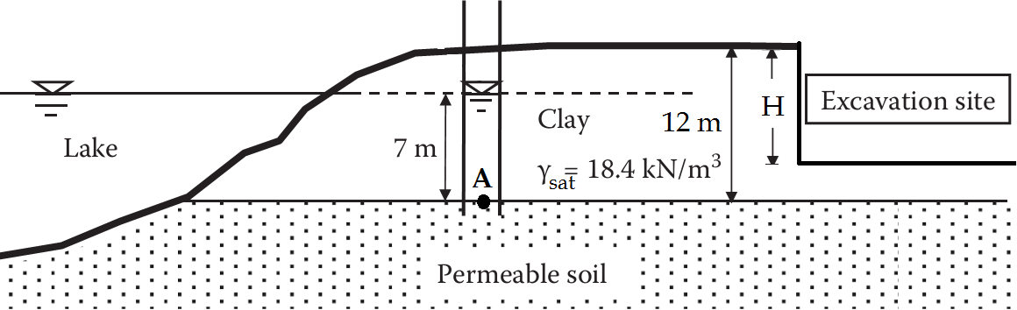

- Foundations with a dimensions of 6x6m, 3x12m and 4x9m will be constructed on the soil profile in housing estate shown below,
- If the transmitted stress from foundations to ground surface is equal to q=300 kN/m², estimate the foundation settlement that will be maximum among given foundations (Calculate the stress increase (Δσ) by 2:1 Method).
- Compute the settlement of the foundation A due to primary consolidation of the clay layer (Calculate the stress increase (Δσ) by 2:1 Method).
- Determine the time required for 90% consolidation to take place in the field.

U (%) | 10 | 20 | 30 | 40 | 50 | 60 | 70 | 80 | 90
T_{v} | 0.008 | 0.031 | 0.071 | 0.126 | 0.197 | 0.287 | 0.408 | 0.567 | 0.848

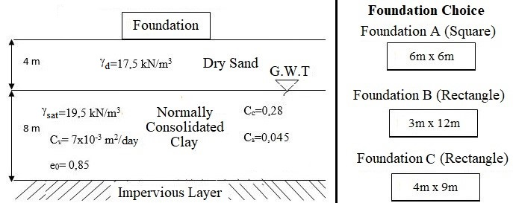

- A series of CD triaxial tests were carried out on undisturbed normal consolidated clay samples and friction angle of the clay soil was found to be ′=30º. Another series of CU triaxial tests were carried out for different soil samples at same point and test results were obtained as follows:
Test | Cell Pressure (kPa) | Deviatoric Stress (kPa) | Pore Pressure, Uf (kPa)
1.CU Deneyi | 250 | 175 | ?
2.CU Deneyi | 400 | 280 | ?

- Compute the effective and total shear strength parameters of the clay soil.
- Compute the pore pressures for given above CU tests at failure.
c) Compute the shear stresses in terms of effective and total stress at point M given below figure.
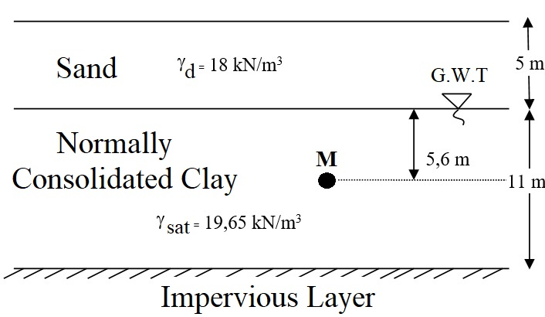

- The soil samples were recovered from the silty clay soil in borrow area and max. unit weight (γ_{kmax}), optimum water content (w_{opt}) and specific gravity of the soil samples were found to be 19.0 kN/m³, 14%, and 2.72 in the laboratory, respectively. A volume of 0.15 m³ hole was excavated in the borrow area and moist weight and dry weight of the soil sample were found to be 1.95 kN and 1.77 kN, respectively.
  - Calculate how much excavated soil is necessary to construct a compacted fill of 7000 m³ assuming relative compaction of 100%.
  - If there has been a 25% loss of water during transportation from borrow area, determine if there is a need of addition of water during the construction of the fill and calculate volume of the water in the fill.

Time is 90 minutes. Good Luck…

